Activity Week!
JPC offered an exciting opportunity to promote the great outdoors to students as part of the first ACTIVITY WEEK!
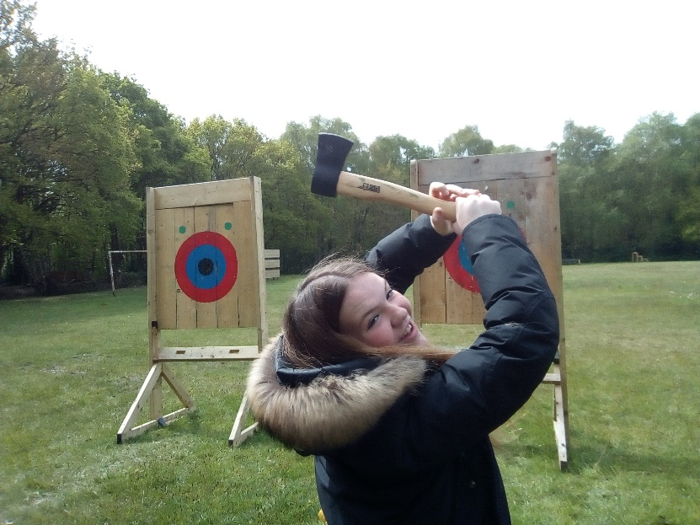
Some of the activities offered to students were Axe Throwing and Archery at Wirral’s local Activities Centre in Storeton called Barnstondale. Students were challenged to develop skills such an aiming and throwing whilst understanding the importance of patience and calmness when learning a new skill.
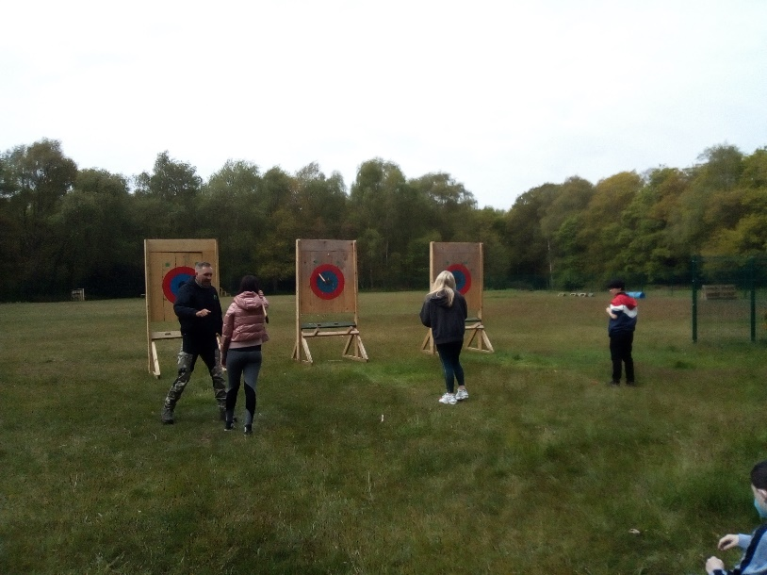
JPC continued ACTIVITY WEEK with an afternoon of activities hosted in Birkenhead Park! Students had a range of activities to choose from such as; Tennis, Outdoor Games, Walk around the park, Bowls and Bike riding.

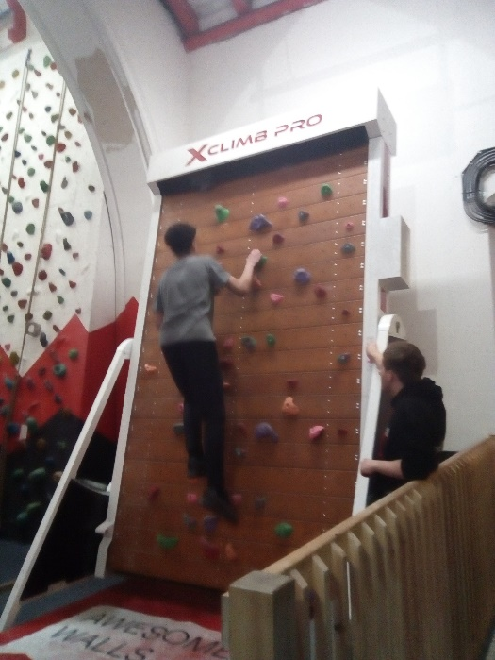
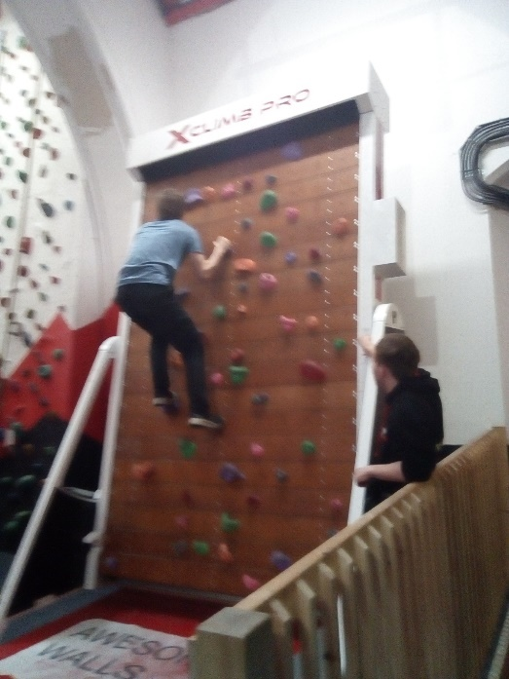

Year 11s were given a break from their exam studies and were offered an after school activity to Awesome Walls Liverpool! They traded their pens and papers for harnesses and steep climbs, but they all had the most amazing time. We’ll miss your determination! Well done for all your hard work Year 11s!

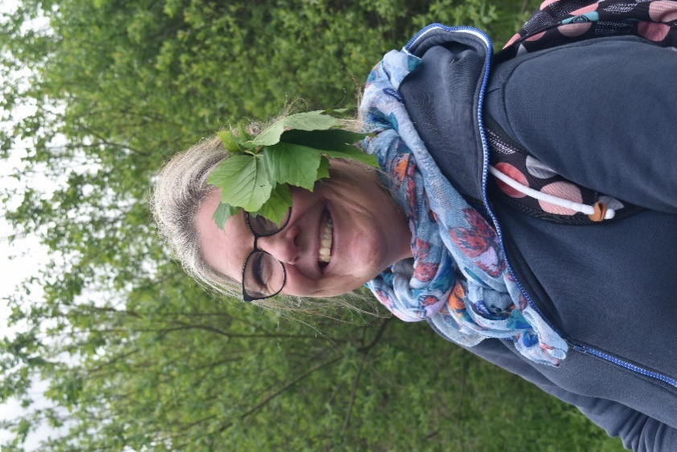

It was not just the students who enjoyed ACTIVITY WEEK, the teachers also took part in the activities and as you can see they loved it just as much as the students. Activity week finished off with a trip that was funded by Andy Yates and the Open Eye Gallery, and thanks to their generosity they provided us with a coach to take the whole school! This trip took place as part of a tree project through a partnership with Mersey Forest Trust, helping young people see the importance of being in nature.

