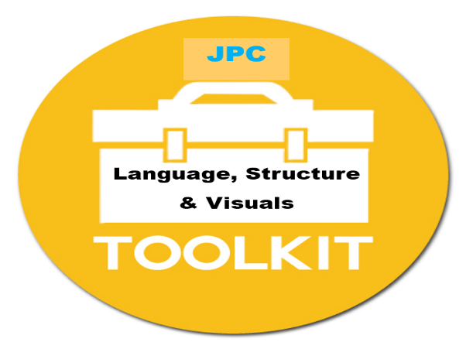
No. | Strategy | What is it?  To reduce the anxiety of the unknown
1 | Learning Journey | A visual plan of the order of activities within a lesson
2 | Change Board | A visual plan of any changes to the school day. E.g. Cover teacher, trips, photographs of any visitors
3 | Visual Task Plan | A prompt sheet of individual tasks to help scaffold instructions
4 | Word Webs | A SALT influenced strategy to support the learning of complex vocabulary
5 | Mind Maps | A SALT influenced strategy to support strand of learning
6 | Social Stories / Visual Plans  JPC social stories / visual plans | A visual plan to inform students of new or different activities
7 | Social Thinking | A SALT influenced strategy that develops better social communication and problem solving
8 | Chat Cartoons | A SALT influenced strategy to support perspective taking and problem solving
9 | Form Change Board | A visual outline of any changes to the day for an individual Form Group
10 | TA Individual Timetables | A short-term strategy to reduce anxiety
11 | Now and Next | Visual schedule to help with structure
12 | Comprehension Monitoring | Delivered via cooking to explore students understanding of instructions

