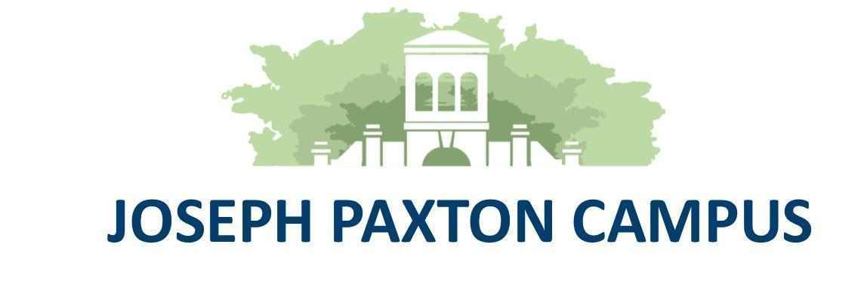

**Wirral Hospitals’ School**

***“Working together to make everything better”***

**An Ofsted “Outstanding” School**

**Headteacher: Mr P Arrowsmith**

Joseph Paxton Campus, 157 Park Road North, Claughton, Wirral. CH41 0DD

Tel: 0151-488-7680

e-mail: [schooloffice@wirralhs.co.uk](mailto:schooloffice@wirralhs.co.uk) Website [www.wirralhs.co.uk](http://www.wirralhs.co.uk)

7th May 2025

Dear Parent / Carer

**Conway Centre trip - Wednesday 1st to Friday 3rd October 2025**

Joseph Paxton students have an exciting opportunity to visit the Conway Centre in Anglesey for a 2-night, 3-day outdoor education trip.

The dates for this trip are Wednesday 1st October to Friday 3rd October.

The trip will involve taking part in activities such as Climbing, Canoeing, Bush Craft and Team Building. There are so many different ways that your child may benefit from this experience, above all we hope that it will show them what they are capable of and provide some happy memories.

The cost for the trip will be £200 and will cover all food, accommodation, transport, safety equipment and expert outdoor instructors. School may be able to make a contribution for any student who is currently in receipt of free school meals, please discuss this with us in the first instance.

We are also happy to agree to a payment plan for other families where the cost of the trip might

prove to be a barrier.

Please discuss the trip with your child and reply with a deposit of £50 by Friday 13th June to reserve a space. A deposit must be submitted with the consent letter to secure a place. If you need any more information please call the school office and ask for me.

Yours sincerely

T Lewis

Mr Terence Lewis

Learning Beyond the Classroom Co-ordinator

**Trip to**

**Conway Centre**

**1st to 3rd October 2025**

Name of child/ward ……………………………………………………………………………………………..

I have read the letter and my child/ward wishes to take part in the trip. I am aware that the cost of the trip is £200:

Yes **⭘**

No **⭘**

I enclose £50 for the deposit for the trip (a place can only be secured with the £50 deposit)

Yes **⭘**

My child is in receipt of free school meals and I would like to discuss the payments with Mr Lewis

Yes **⭘**

No **⭘**

I will require a payment plan

Yes **⭘**

No **⭘**

My child/ward agrees to mature and responsible behaviour throughout the trip

Yes **⭘**

Signature of Parent / Guardian: ……………………………………………………………………………….

**Please return to the school office with the £50 deposit by Friday 13th June**