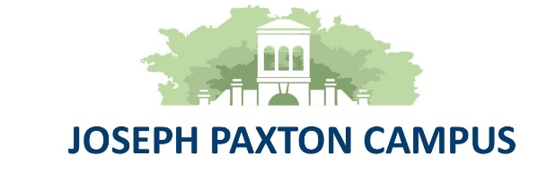

Year 11 Revision Support for Mock Exams
21 – 24 November & 28 November – 1 December
To Year 11 Students
After School Study Sessions
Subject staff will be available to support you throughout the next two weeks.
Please go to the room on the list and then staff will arrange where you can go.
You can also stay in school during these times to complete your own individual revision.
If you are staying in school until 3.30pm parents MUST either email or telephone school with their consent.

Day | Subject | Subject
Monday | English F8
Tuesday | Maths G7 | Chemistry G8
Wednesday | Options | Biology G8
Thursday | Options | Physics G11

Revision materials from your class teachers will be available on your google classroom. Other resources may also be on GCSE POD.
On order to access these online resources you will need your email and a password. Your Form Tutors will make sure you know what these are.

Login details for GSCE POD are the same as Google Classroom,
So, Joe Bloggs of Elm will be:
stu_jbloggs@wirralhs.co.uk
JBelm2023

Staff will also support you in lessons and prepare you for the mock examination week.
Goodluck!

